ParseData With Dots and Commas

Taken inputdata as below

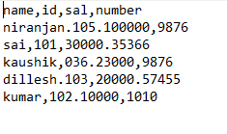

And taken data formate as below

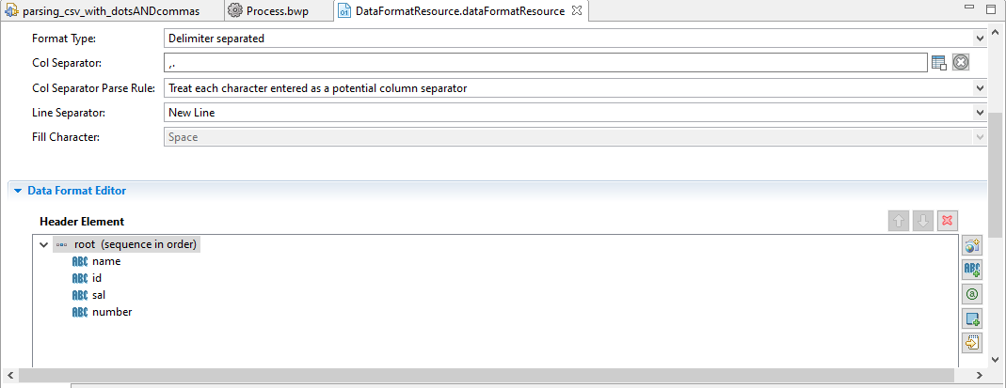

**Take in column separator** (**, and .**)